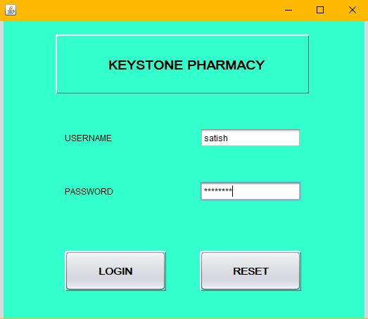

FOR LOGIN BUTTON:

String s1=t1.getText();

String s2=new String(p1.getPassword());

if(s1.equalsIgnoreCase("satish") && s2.equals("password"))

{

new frame2().setMaximumSize(null);

new frame2().setVisible(true);

}

else

{

j1.showMessageDialog(null,"Incorrect Password/Username");

}

t1.setText(" ")

p1.setText(" ");

**CUSTOMER DETAILS**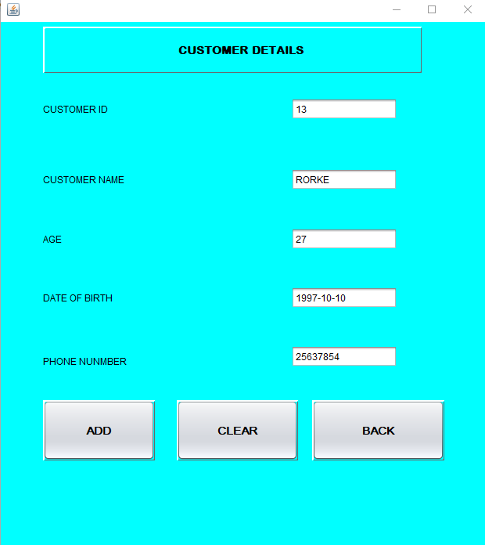

FOR ADD BUTTON

try{

Class.forName("com.mysql.jdbc.Driver");

Connection con=DriverManager.getConnection("jdbc:mysql://localhost:3306/Keystone_Pharmacy","root","agp3sss");

Statement stmt=(Statement) con.createStatement();

String query="insert into customer values("+ t2.getText()+", '"+ t3.getText()+"', "+ t4.getText()+", '"+ t5.getText()+"' ,'"+ t6.getText()+"'"+");";

stmt.executeUpdate(query);

J.showMessageDialog(null,"RECORD ADDED");

stmt.close();

con.close();

}catch(Exception e) {

j2.showMessageDialog(null,e.getMessage());

}

FOR CLEAR BUTTON

t2.setText(" ");

t3.setText(" ");

t4.setText(" ");

t5.setText(" ");

t6.setText(" ");

FOR BACK BUTTON

new frame2().setVisible(true);

this.setVisible(false);

**FOR MEDICINE DETAILS**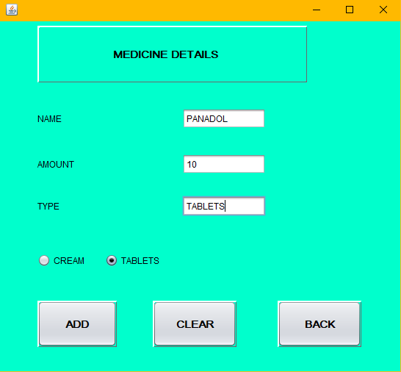

**FOR ADD BUTTON**

try{

Class.forName("com.mysql.jdbc.Driver");

Connection con=DriverManager.getConnection("jdbc:mysql://localhost:3306/Keystone_Pharmacy","root","agp3sss");

Statement stmt=(Statement) con.createStatement();

String query="insert into medicine values('"+t7.getText()+"','"+t8.getText()+"','"+t9.getText()+"' "+");";

if(o1.isSelected()==true)

{

t9.setText("tablets");

}

else if(o2.isSelected()==true)

{

t9.setText("cream");

}

stmt.executeUpdate(query);

Jo.showMessageDialog(null,"RECORD ADDED");

stmt.close();

con.close();

}catch (Exception e){

J1.showMessageDialog(null,e.getMessage());

}

FOR CLEAR BUTTON

t7.setText(" ");

t8.setText(" ");

t9.setText(" ");

FOR BACK BUTTON

new frame2().setVisible(true);

this.setVisible(false);

**FOR PAYMENT DETAILS**

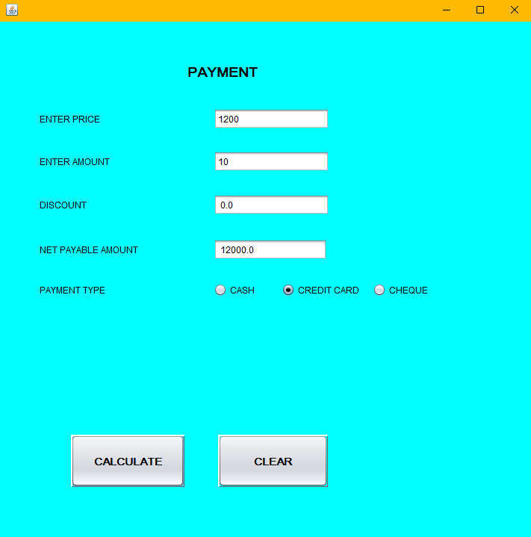

**FOR CALCULATE BUTTON**

try{

Class.forName("com.mysql.jdbc.Driver");

Class.forName("java.sql.Driver");

Connection con=DriverManager.getConnection("jdbc:mysql://localhost:3306/Keystone_Pharmacy","root","agp3sss");

Statement stmt=(Statement) con.createStatement();

String query="insert into payment values("+ t10.getText()+", "+ t11.getText()+", "+ t12.getText()+", "+ t13.getText()+", "+");";

double pr=Double.parseDouble(t10.getText());

double a=Double.parseDouble(t11.getText());

double amount = a*pr;

double discount = 0;

double net;

{

{

if(o3.isSelected()==true)

{

discount=(11*amount)/100;

}

else if(o4.isSelected()==true)

{

discount=(0*amount)/100;

}

else if(o5.isSelected()==true)

{

discount=(7*amount)/100;

}

t12.setText(" "+discount);

}

net= amount-discount;

t13.setText(" "+net);

}

stmt.executeUpdate(query);

J1.showMessageDialog(null,"RECORD ADDED");

stmt.close();

con.close();

}catch(Exception e) {

J2.showMessageDialog(null,e.getMessage());

}

FOR CLEAR BUTTON

t10.setText(" ");

t11.setText(" ");

t12.setText(" ");

t13.setText(" ");

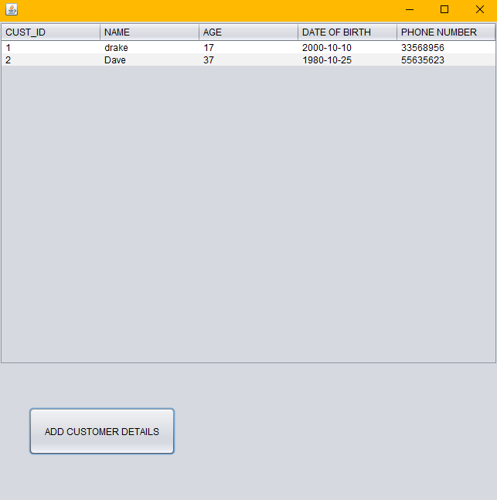

DefaultTableModel model=(DefaultTableModel) T1.getModel();

try {

Class.forName("java.sql.Driver");

Connection con=DriverManager.getConnection("jdbc:mysql://localhost:3306/Keystone_Pharmacy","root","agp3sss");

Statement stmt=con.createStatement();

String query="select * from customer;";

ResultSet rs=stmt.executeQuery(query);

while(rs.next()){

String custid=rs.getString("cust_id");

String name=rs.getString("name");

String age=rs.getString("age");

String dateofbirth=rs.getString("dateofbirth");

String phonenumber=rs.getString("phone_number");

model.addRow(new Object[] {custid,name,age,dateofbirth,phonenumber});

}

rs.close();

stmt.close();

con.close();

} catch (Exception e) {

j4.showMessageDialog(null,e.getMessage());

}

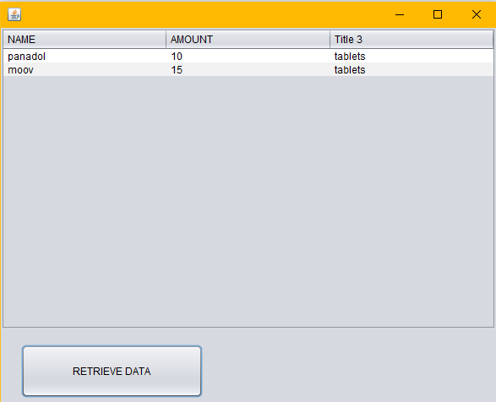

FOR RETRIEVE DATA BUTTON

DefaultTableModel model=(DefaultTableModel) T2.getModel();

try {

Class.forName("java.sql.Driver");

Connection con=DriverManager.getConnection("jdbc:mysql://localhost:3306/Keystone_Pharmacy","root","agp3sss");

Statement stmt=con.createStatement();

String query="select * from medicine;";

ResultSet rs=stmt.executeQuery(query);

while(rs.next()){

String name=rs.getString("name");

String Amount=rs.getString("Amount");

String type=rs.getString("type");

model.addRow(new Object[] {name,Amount,type});

}

rs.close();

stmt.close();

con.close();

} catch (Exception e) {

a1.showMessageDialog(null,e.getMessage());

}

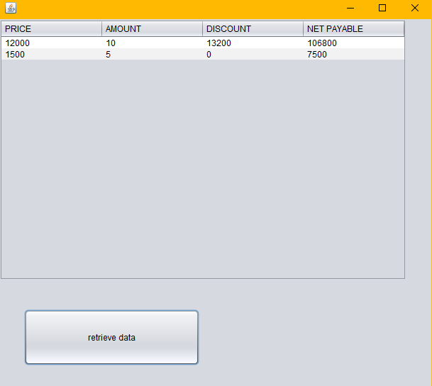

DefaultTableModel model=(DefaultTableModel) T3.getModel();

try {

Class.forName("java.sql.Driver");

Connection con=DriverManager.getConnection("jdbc:mysql://localhost:3306/Keystone_Pharmacy","root","agp3sss");

Statement stmt=con.createStatement();

String query="select * from payment;";

ResultSet rs=stmt.executeQuery(query);

while(rs.next()){

String price=rs.getString("price");

String Amount=rs.getString("amount");

String discount=rs.getString("discount");

String payableamount=rs.getString("payable_amount");

model.addRow(new Object[] {price,Amount,discount,payableamount});

}

rs.close();

stmt.close();

con.close();

} catch (Exception e) {

a2.showMessageDialog(null,e.getMessage());

}

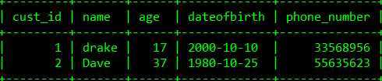

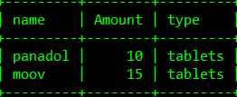

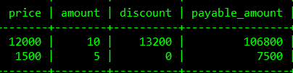

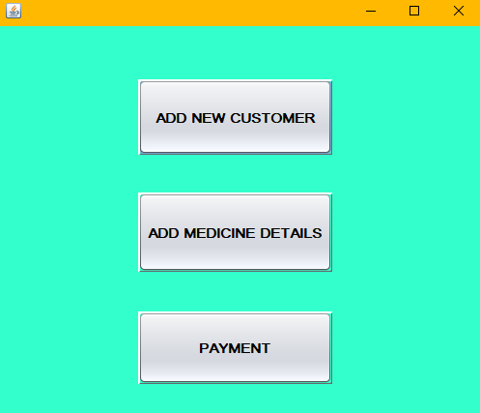

For Add New Customer Button :

new frame4().setMaximumSize(null);

new frame4().setVisible(true);

For Add Medicine Details :

new frame5().setMaximumSize(null);

new frame5().setVisible(true);

For Payment :

new frame6().setMaximumSize(null);

new frame6().setVisible(true);